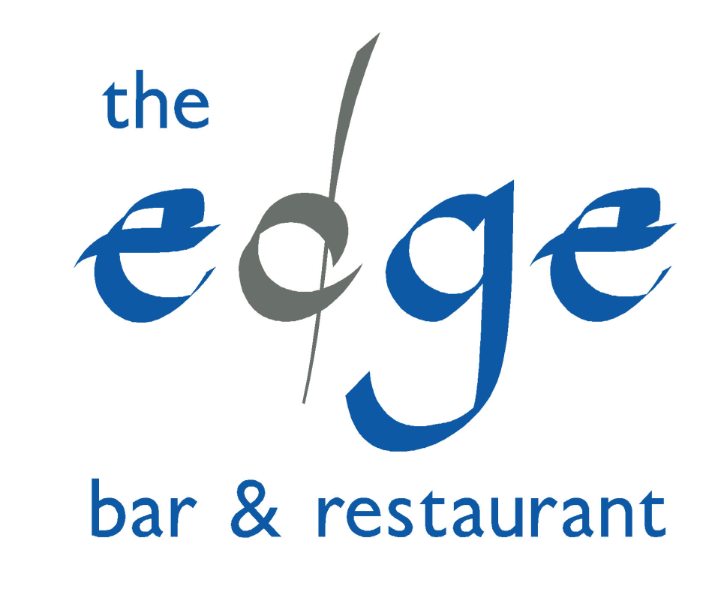

Appetizers

Olives, Bread & Balsamic 3.99

Garlic Bread 2.50

To Start

Homemade Soup of the day & a roll 5.99

Award winning Cornish Blue Cheese, bread crumbed and fried and presented 6.99
on a herb salad with a Cumberland sauce

Moules Mariniere with crusty bread 8.99

Chicken Liver & Brandy Parfait with Carrot Marmalade & Melba Toast 6.99

Crayfish & tomato cocktail with Rocket & Granary Bread 6.99

Main Courses

Local Hake grilled and served on a herb salad with a fresh mango & mint salsa and 15.99
new potatoes.

Roasted breast of Cornish Chicken on a Citrus Couscous and drizzled with a 14.99
balsamic syrup

Moules Mariniere with Aioli and Handcut Chips 14.99

Roasted Rack of Cornish Pork Ribs in BBQ Sauce served with Chips & Onion rings 14.99

Fillet of Salmon marinated in lime, chilli, honey and soy, pan fried and served on 15.99
a new potato & rocket salad

Chargrilled Cornish Fillet Steak with mushrooms, tomato and either hand cut 21.99
chips or mash

Chargrilled Rib-eye Steak as above 19.99
Surf n’ Turf Fillet or Rib-eye Steak, Served as above but with garlic Fillet Steak 23.99
fried Tiger prawns Rib-eye 21.99

Spicy Chicken Fajitas, Chicken, peppers & onions served on a sizzling skillet 14.99
with Jalapenos, Salsa, Sour Cream & Cheese on the side with warm Tortilla Wraps

Dynamite Fajitas, as above but extra spicy and with the addition of prawns 16.99

A trio of Cornish Sausages with mushy peas, olive oil mashed potato & onion gravy 12.99

Battered Haddock & Handcut Chips with Mushy Peas and a homemade 11.99
Tartare relish

Vegetarian Options

Portobello Mushroom Stuffed with tomato and spinach, topped with a herb crust and 12.99
roasted

Fresh Penne Pasta in a sun dried tomato, pesto and cream sauce with fresh parmesan 11.99
shavings

A Medley of Aubergines, Peppers, Red Onions, Garlic, Potatoes and fresh rosemary 12.99
roasted and served w ith lightly grilled goats cheese

Salads

Handpicked Port Isaac Crab dressed in its shell and served on a fresh Nicoise Salad 15.99

Roasted Cornish Chicken breast and mango Salad 11.99

Little Tykes

Chicken Goujons and mash or fries 5.99

Small Battered Fish & Chips 5.99

Penne Pasta & Cheese 5.99

